Module 4 - Building API

Implementation:

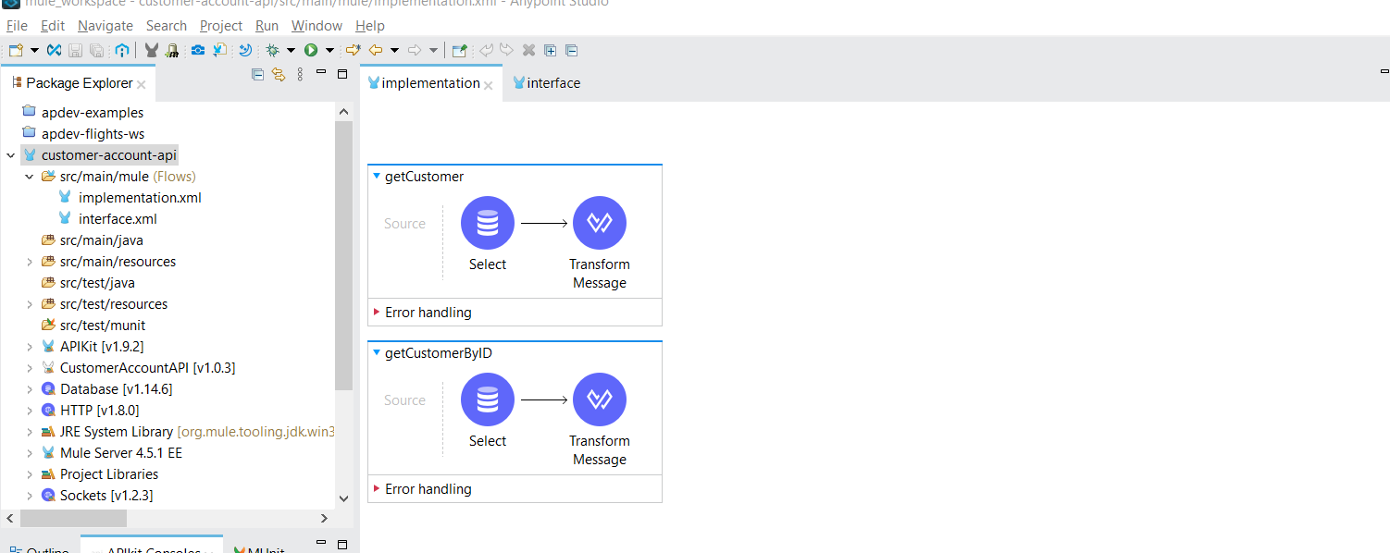

Interface:

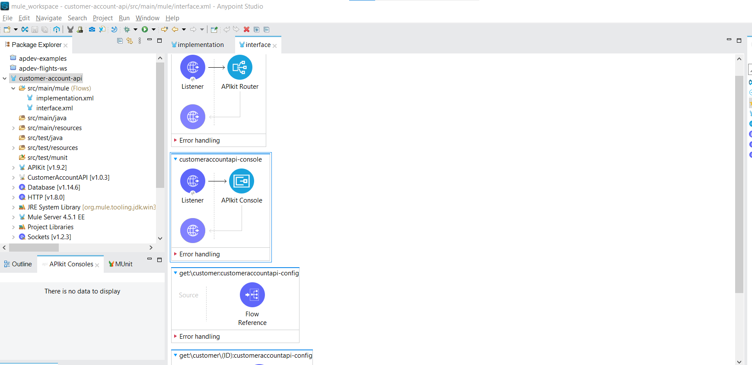

#%RAML 1.0

title: CustomerAccountAPI

types:

CustomerAccount: !include /examples/CustomerAccountDatatype.raml

/customer:

get:

queryParameters:

accounttype:

required: false

enum:

- personal

- business

name:

required: false

enum:

- Remya

responses:

200:

body:

application/json:

type: CustomerAccount[]

examples:

output: !include /examples/CustomerAccountExample.raml

post:

body:

application/json:

type: CustomerAccount

examples:

input: !include /examples/CustomerNewAccount.raml

responses:

200:

body:

application/json:

example:

message: Customer Account created

/{ID}:

get:

responses:

200:

body:

application/json:

type: CustomerAccount

examples:

output: !include /examples/CustomerAccountByID.raml

404:

body:

application/json:

example:

message: {"message": "Account not found"}

